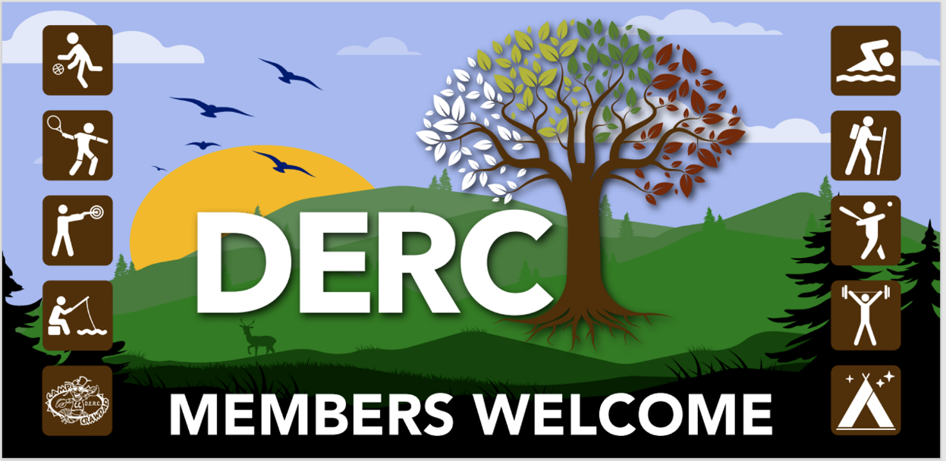
2024 DERC Membership Auto Withdraw Application
CONSUMER DEBIT AUTHORIZATION FOR QUARTERLY AND YEARLY ONLY
Memberships are from January 1 through December 31.

Name: _________________________________________________________________
Employer: _______________________________________________________________
Home address: ___________________________________________________________
City/ST/Zip: _____________________________________________________________
Email __________________________________________________________________
Home/Office Phone: ________________________ Cell: __________________________
Eligible Immediate Family Member(s): ________________________________________
________________________________________________________________________
Please deduct my DERC Dues Payment from my account:

Name of Bank/Savings & Loan/Credit Union: ___________________________________
Account Type: Checking _____________________ Savings ________________________
Routing Number_______________________ Account Number_____________________
Withdraw Period: Quarterly_________ Yearly__________
I authorize “DERC Recreation Club” to deduct my dues from the account listed above. I understand that if I decide to discontinue this payment plan, I will notify “DERC Recreation Club” in writing at the following address:
DERC Membership
252 Downey Road
Washington, WV 26181.
SIGNATURE: _________________________________________ DATE: _________________
NOTE: Attach a voided check or savings deposit slip with this form for accuracy.
Please return the form and attachment to Lora Caplinger, 252 Downey Road, Washington, WV 26181, or email to DERC Membership Chair at loracaplinger@outlook.com

